

NAME – VAIBHAV KHARE

EMAIL ID – [VAIBHAV.KHARE96@GMAIL.COM](mailto:VAIBHAV.KHARE96@GMAIL.COM)

Assignment 0 – Create a simple shell script to . tell the user about their session – they need to know:

* What their username is
* What the current date is
* What the time is
* What their current working directory is
* How many files they have in that directory
* What is the biggest file in their current directory

Ans –

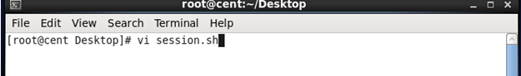

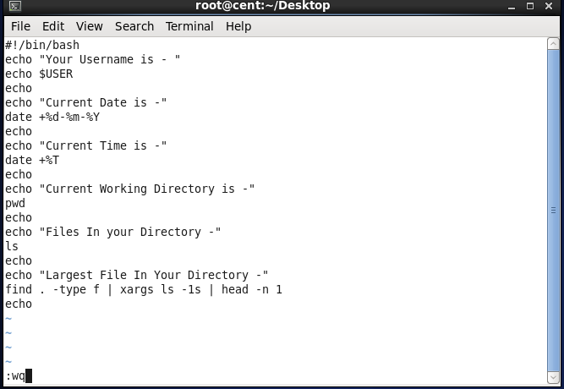

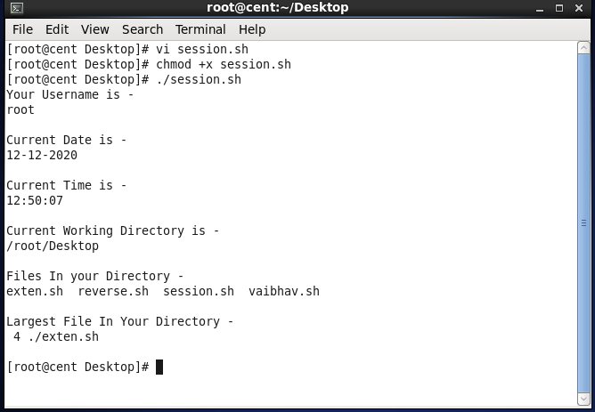

Assignment 1 – Create a directory with a few test files in it (the files can be empty). Now write a script that for every file in that directory you rename to have an extension of today’s date in YYYYMMDD format.

Ans –

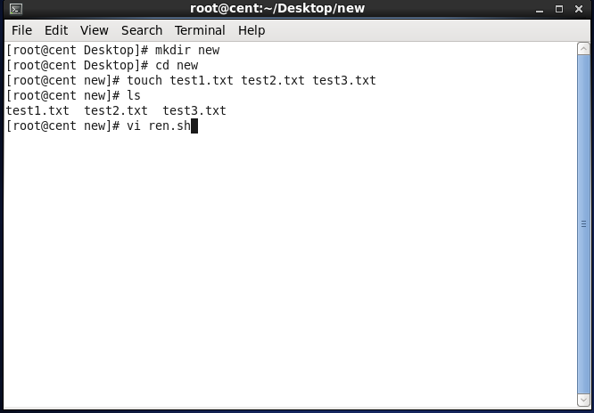

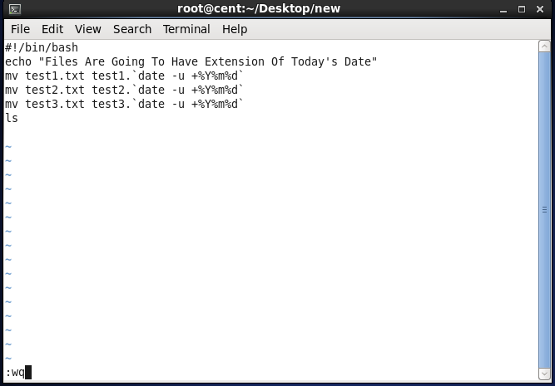

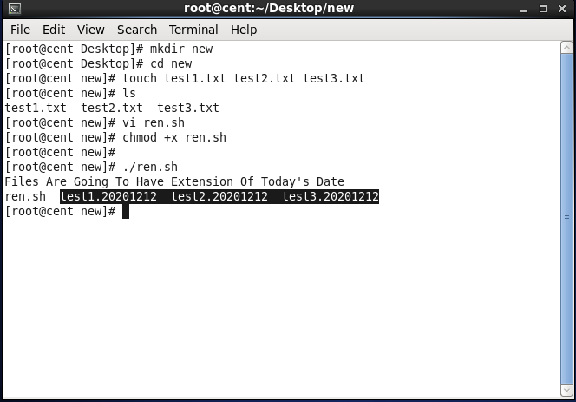

ASSIGNMENT 2 – Write a script that takes a number as an input and reverses it out to the user. For example, if the original number is 74985, the output should be 58947.

